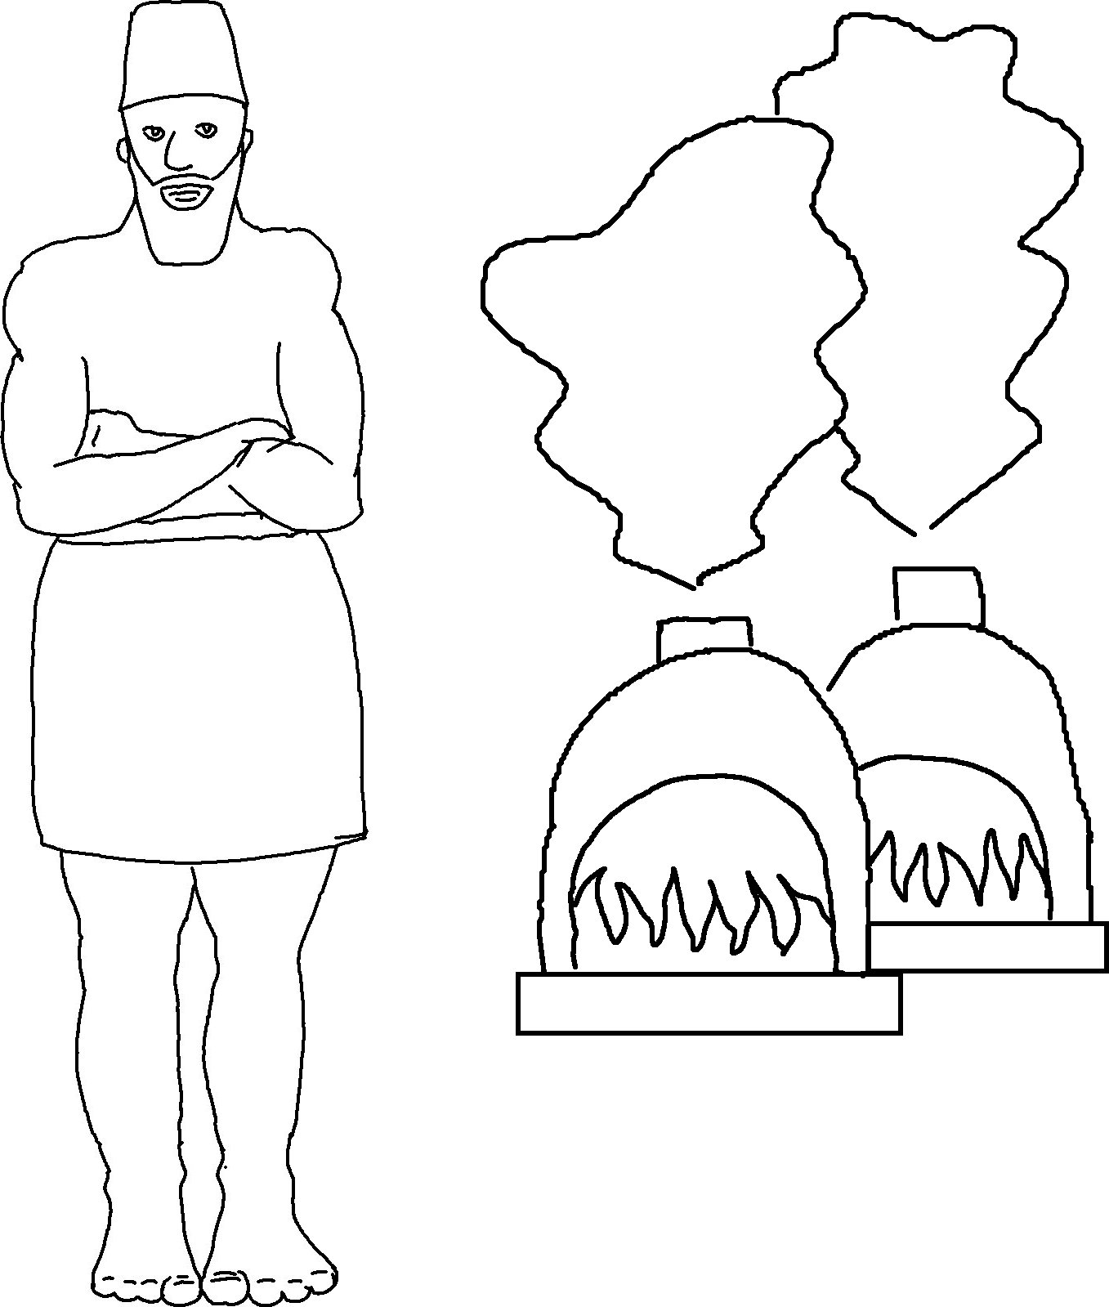

I am the Lord your God.
I am holding your hand,
so don't be _ _ _ _ _ _.
I am here to _ _ _ _ you.
Isaiah 41:13_{CEV}

